Figure 1
Conceptual framework of the hypothesized moderated mediation model
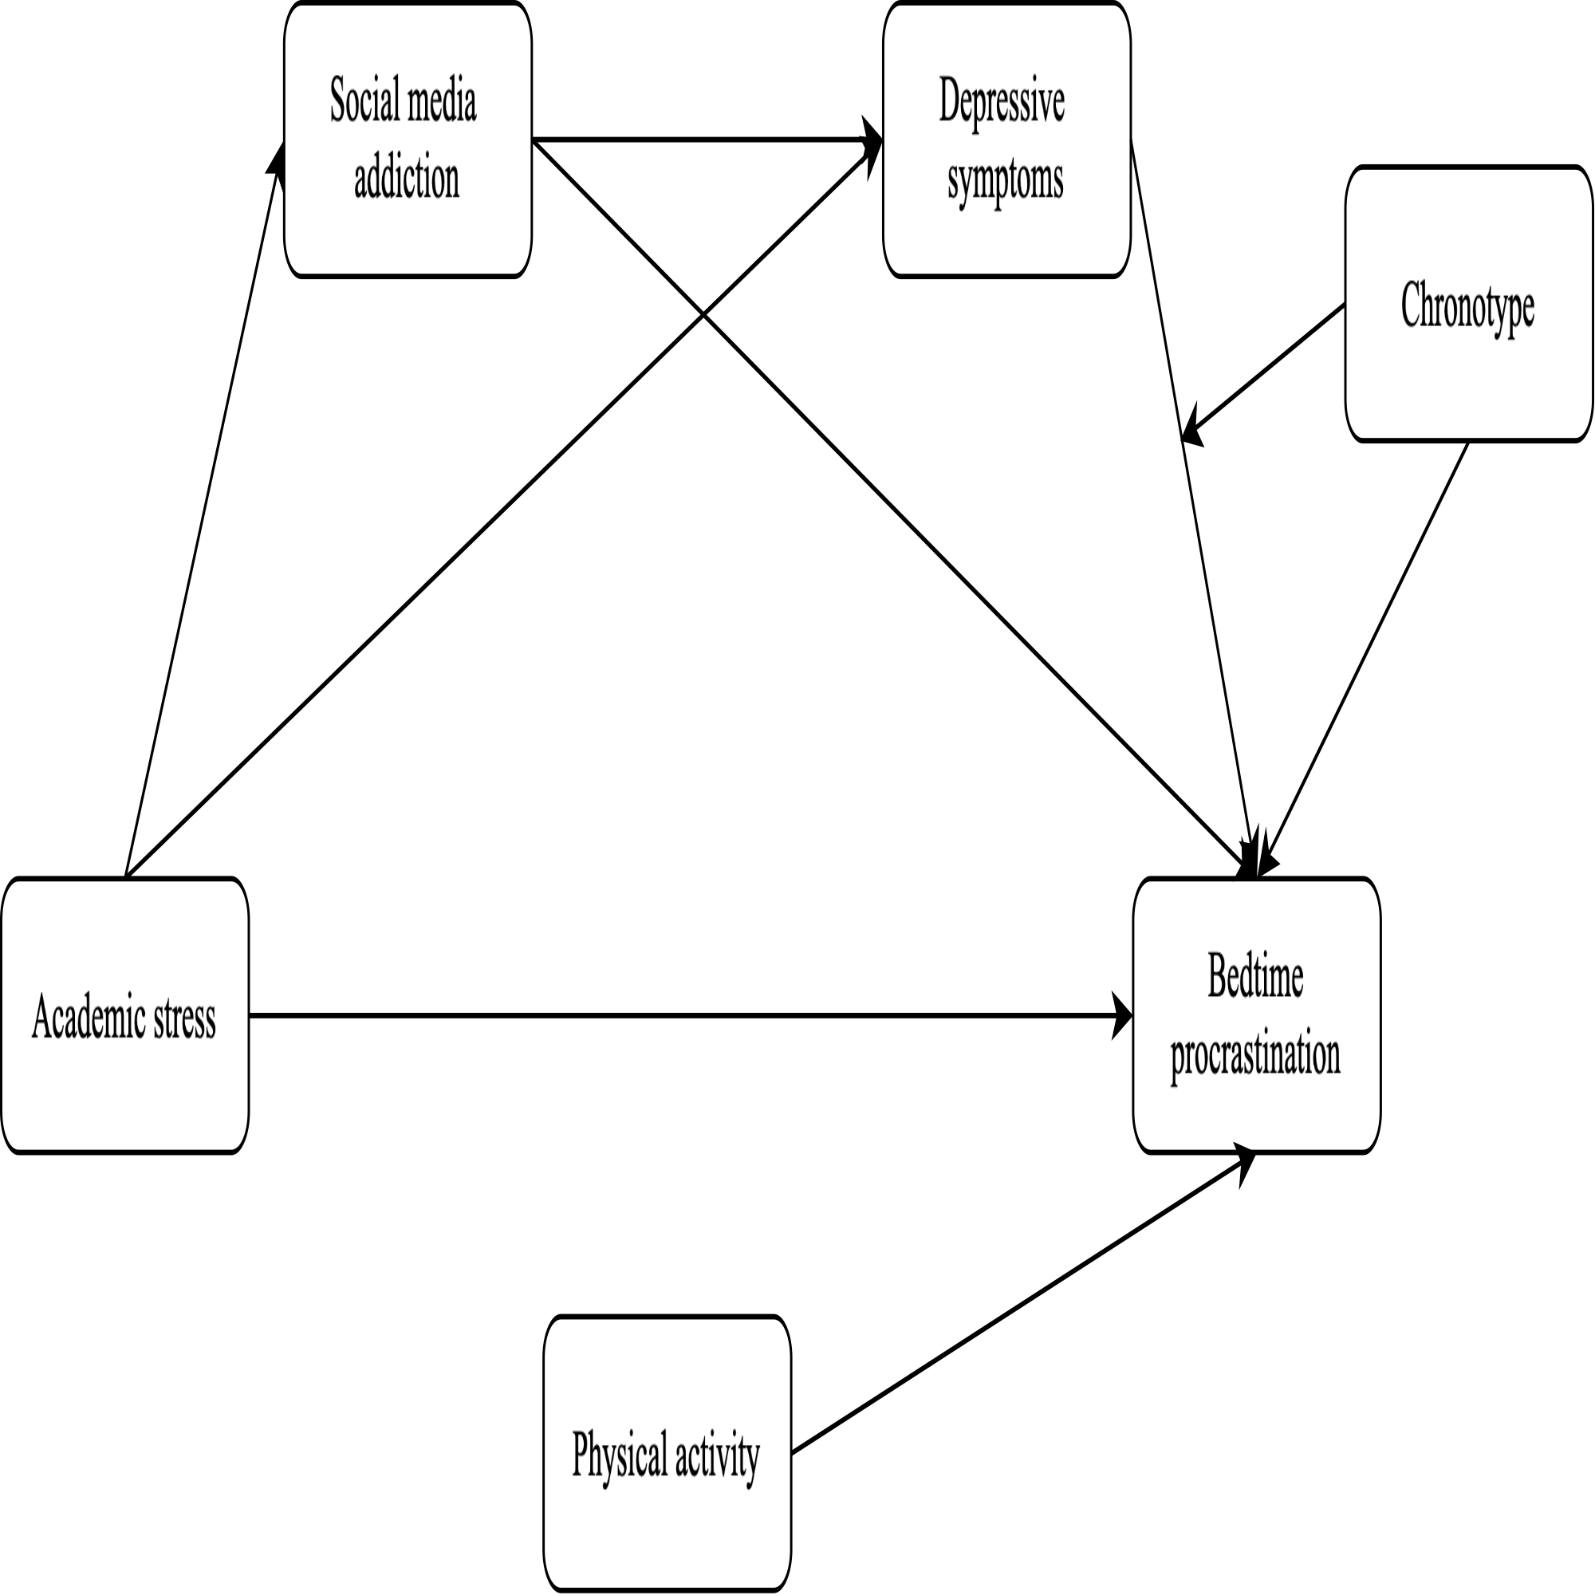
Note. Proposed model

